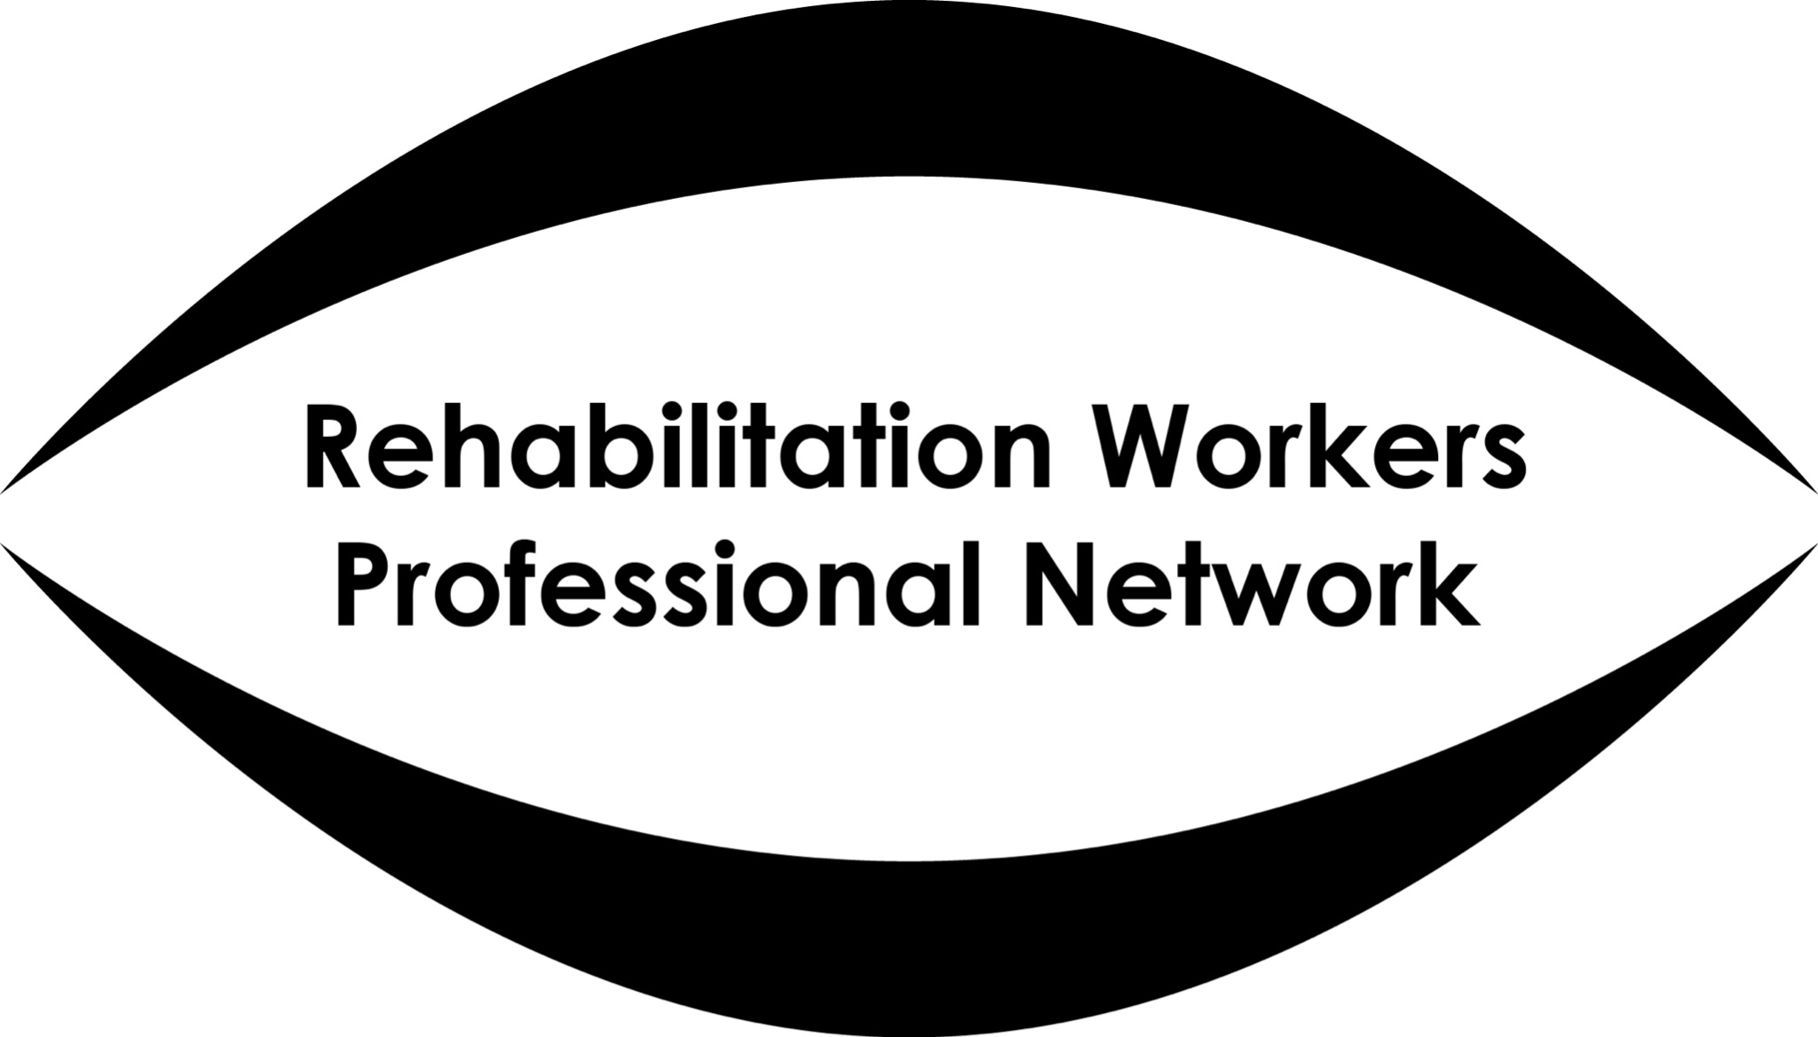

Duty of Candour – RWPN Policy Statement

The professional duty of candour
All members and registrants of RWPN must be open and honest with clients when something goes wrong, or something they have done causes distress, in the course of their work with a client. This means that you must:
- tell the client (or, where appropriate, the client’s family, carer or advocate) when something has gone wrong
- apologise to the client (or, where appropriate, the client’s family, carer or advocate)
- offer an appropriate remedy or support to put matters right (if possible)
- explain fully to the client (or, where appropriate, the client’s family, carer or advocate) the short and long-term effect of what has happened
RWPN’s members and registrants must also be open and honest with their colleagues and employers.
RWPN’s Code of Ethics and Professional Conduct provides practitioners with a framework for promoting and maintaining good safe and professional behaviour and practice. Integrity and good conduct are at the heart of the code. Paragraph 1.1. of the code states that a registrant has “a duty to be able to account for their actions in practice in accordance with the values and principles of RWPN’s Code of Ethics and Professional Conduct”.

Promoting wellbeing as a component of professional competence
To be deemed as “competent” you need a combination of knowledge, skills and behaviours. You may learn knowledge and skills through professional training and/or experience and continuing professional development, but these elements alone are not necessarily what make you a good or safe practitioner. You must also demonstrate behaviours that promote and protect the wellbeing of service users and their carers, the wider public and the reputation of employers and the profession.

Your responsibility as a practitioner
Every practitioner has a legal duty of care towards those referred to them. They also have a wider duty of care towards those within their workplaces, whether a person using a service or a colleague. Under the Health and Safety at Work Act 1974, all personnel are required to ensure that all reasonable steps are taken to ensure the health, safety and welfare of any persons involved in any activity for which they are responsible.

Witnessing unprofessional behaviour or an unacceptable situation
Under the duty of care you must act if you see unprofessional behaviour or an unacceptable situation which threatens health, safety or welfare.
RWPN’s Code of Ethics and Professional Conduct states (1.18) that the professional should seek “to protect the integrity of the profession and their employing organisation, but on witnessing malpractice or unprofessional conduct on no account remain silent about it”.
You will need to use your professional judgement and experience to know whether to act immediately, or if there is a more appropriate time and place. You must only act within your professional competence.
If you see a person being harmed, being put at risk or being denied their human rights and dignity, then you should act immediately. If you can intervene to improve or make a situation right, without endangering yourself or another person, you should do so. Call for help if you can. You will need to assess and respond to the immediate needs of the person involved.

Recording your concerns and your actions
You should record clearly and objectively the activity that you have witnessed that raises a concern. You should also record any action you have taken, with any outcomes and agreed further actions. This record should contain dates and timescales. You may wish to refer back to this when you report your concerns.

Tackling the unprofessional behaviour of a colleague
Any concern about the technical competence, the quality of work or the integrity of a professional should be expressed with due care to protect the reputation of that person. Any concern must be objective, evidence-based where possible and raised through appropriate channels.
Should you have reasonable grounds to believe that the behaviour or professional performance of a colleague may be deficient in the standards of professional competence, you should report your concerns (see ‘Reporting your concerns’ below).

Disclosure
Under the Public Interest Disclosure Act 1998, an employed individual has the right to make a “protected disclosure” where they believe:
- that a criminal offence has been committed, is being committed, or is likely to be committed
- that a person has failed, is failing to, or is likely to fail to comply with any legal obligation to which they are subject
- that a miscarriage of justice has occurred, is occurring, or is likely to occur
- that the health or safety of any individual has been, is being, or is likely to be endangered
- that the environment has been, is being, or is likely to be damaged or
- that information tending to show any matter falling within any one of the preceding paragraphs has been, is being or is likely to be, deliberately concealed.
Vision Rehabilitation Specialists and Qualified Habilitation Specialists are encouraged to report all instances where they believe that any of the above circumstances are occurring.

Reporting your concerns
People who raise concerns about malpractice in an organisation or workplace are legally protected by the Public Interest Disclosure Act 1998 (or the Public Interest Disclosure (Northern Ireland) Order 1998 in Northern Ireland). The act protects “whistle-blowers” against victimisation or dismissal, provided they have behaved responsibly in dealing with their concerns.
Section 3 of RWPN’s Code of Ethics and Professional Conduct requires a registrant “to familiarise themselves and comply accordingly with all appropriate workplace policies and procedures, including those for grievance, whistleblowing or misconduct, incompetence, unethical behaviour or negligence by a colleague”.

If the concern relates to a colleague in your own organisation you should raise these concerns, in the first instance, with your line manager or other appropriate manager/supervisor, either verbally or in writing. Any information you give must be objective and capable of substantiation. Your disclosure should be “protected” and you should not suffer detriment as a result. Further advice on your organisation’s policy on raising concerns should be obtainable from your HR/personnel department or through your union representative.
If the concern relates to a colleague working for another organisation, you would need to notify RWPN in the first instance and discuss with us whether you wish to raise a concern or complaint via RWPN’s Concerns and Complaints policy.

Your responsibility as a manager
All line managers and designated officers should be trained in issues to do with handling an employee’s concerns. The manager should know:
- the organisation’s policy on whistleblowing
- the value and importance of an open and accountable workplace
- how to inform their staff on arrangements
- how to handle concerns/disclosures fairly and professionally
- how to distinguish whistleblowing from grievances
- that it is a disciplinary matter a) to victimise a bona fide whistle-blower and b) for someone maliciously to make a false allegation
- how to protect staff who raise a genuine concern
- how to manage expectations of confidentiality, and
- where staff can get help or refer a concern if the usual channels of communication are blocked or inappropriate to use, for example an outside organisation or an independent helpline offering confidential advice.

Useful links for further information
Health and Care Professions Council (HCPC) https://www.hcpc-uk.org.uk/standards/meeting-our-standards/raising-concerns-openness-and-honesty/the-duty-of-candour/the-duty-of-candour-in-practice/
.gov.uk https://www.gov.uk/whistleblowing/who-to-tell-what-to-expect

Protect - a national charity to support and advise on whistleblowing https://protect-advice.org.uk/

Unison Whistleblowing policy https://unison.org.au/cms_uploads/docs/whistleblower-policy.pdf#:~:text=Unison%20has%20engaged%20an%20independent%20service%20provider%20Your,address%20the%20concerns%20raised%20by%20this%20report%20promptly.

September 2023

